**Experiment-3**

**Aim of the experiment:- Creating and Configuring Virtual private cloud to launch a Web Server**

**Task 1: Create Your VPC**

1. In the search box to the right of Services, search for and choose VPC to open the VPC console.
2. Begin creating a VPC.
3. In the top right of the screen, verify that N. Virginia (us-east-1) is the region.
4. Choose the VPC dashboard link which is also towards the top left of the console.
5. Next, choose Create VPC.
6. Configure the VPC details in the VPC settings panel on the left:
   1. Choose VPC and more.
   2. Under Name tag auto-generation, keep *Auto-generate* selected, however change the value from project to lab.
   3. Keep the IPv4 CIDR block set to 10.0.0.0/16
   4. For Number of Availability Zones, choose 1.
   5. For Number of *public* subnets, keep the 1 setting.
   6. For Number of *private* subnets, keep the 1 setting.
   7. Expand the Customize subnets CIDR blocks section
      1. Change Public subnet CIDR block in us-east-1a to 10.0.0.0/24
      2. Change Private subnet CIDR block in us-east-1a to 10.0.1.0/24
   8. Set NAT gateways to In 1 AZ.
   9. Set VPC endpoints to None.
   10. Keep both DNS hostnames and DNS resolution *enabled*.

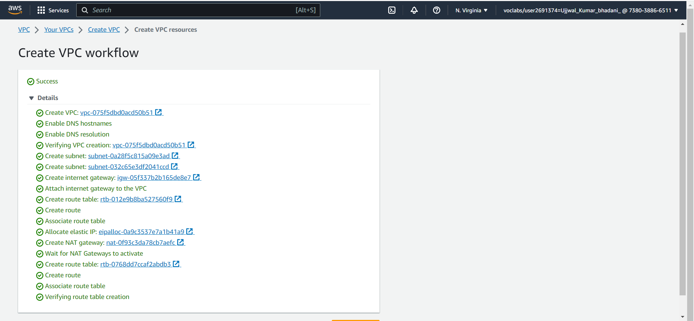

1. In the *Preview* panel on the right, confirm the settings you have configured.
   1. VPC: lab-vpc
   2. Subnets:
      1. us-east-1a
         1. *Public* subnet name: lab-subnet-public1-us-east-1a
         2. *Private* subnet name: lab-subnet-private1-us-east-1a
   3. Route tables
      1. lab-rtb-public
      2. lab-rtb-private1-us-east-1a
   4. Network connections
      1. lab-igw
      2. lab-nat-public1-us-east-1a
2. At the bottom of the screen, choose Create VPC
3. Once it is complete, choose View VPC

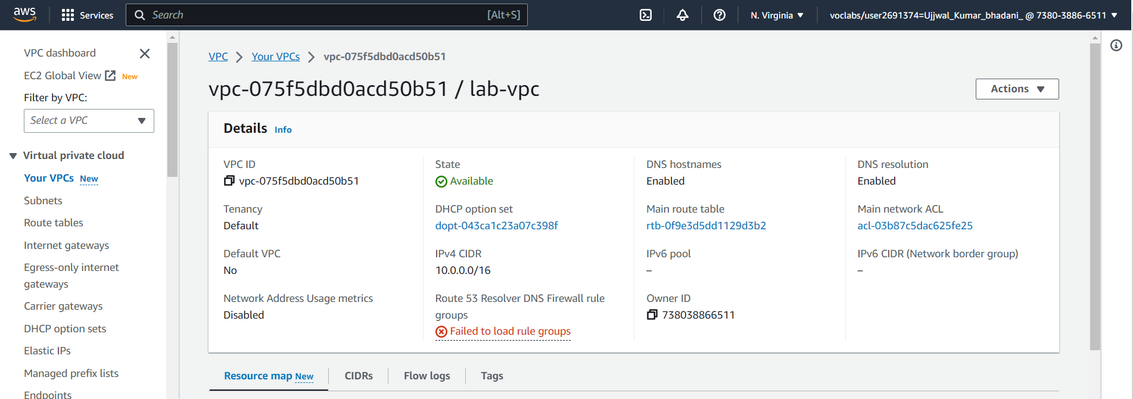

**Task 2: Create Additional Subnets**

1. In the left navigation pane, choose Subnets.
2. Choose Create Subnet then configure:
   1. VPC ID: lab-vpc (select from the menu).
   2. Subnet name: lab-subnet-public2
   3. Availability Zone: Select the *second* Availability Zone (for example, us-east-1b)
   4. IPv4 CIDR block: 10.0.2.0/24

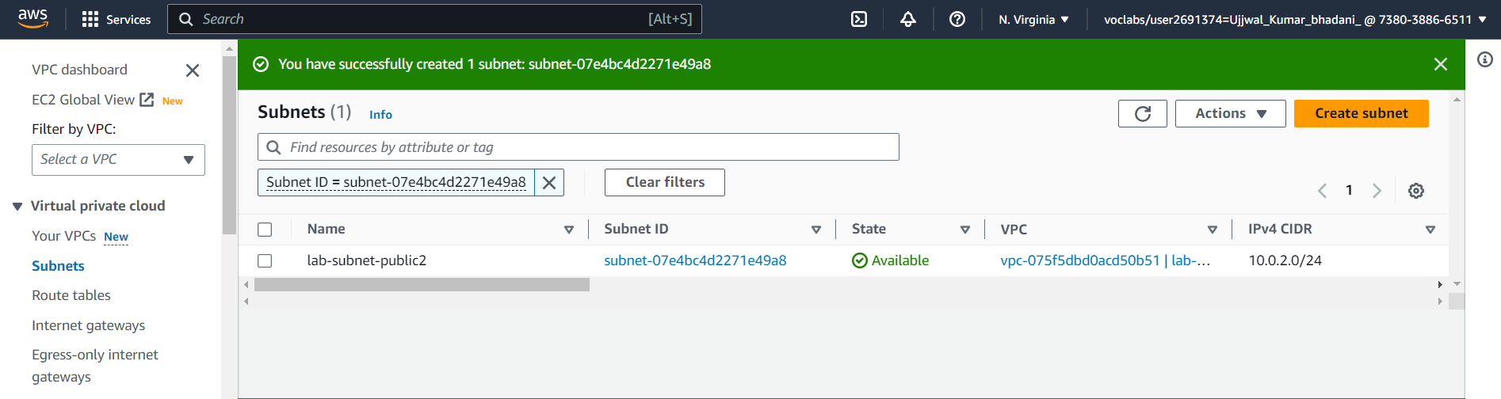

1. Choose Create subnet
2. Choose Create subnet then configure:
   1. VPC ID: lab-vpc
   2. Subnet name: lab-subnet-private2
   3. Availability Zone: Select the *second* Availability Zone (for example, us-east-1b)
   4. IPv4 CIDR block: 10.0.3.0/24

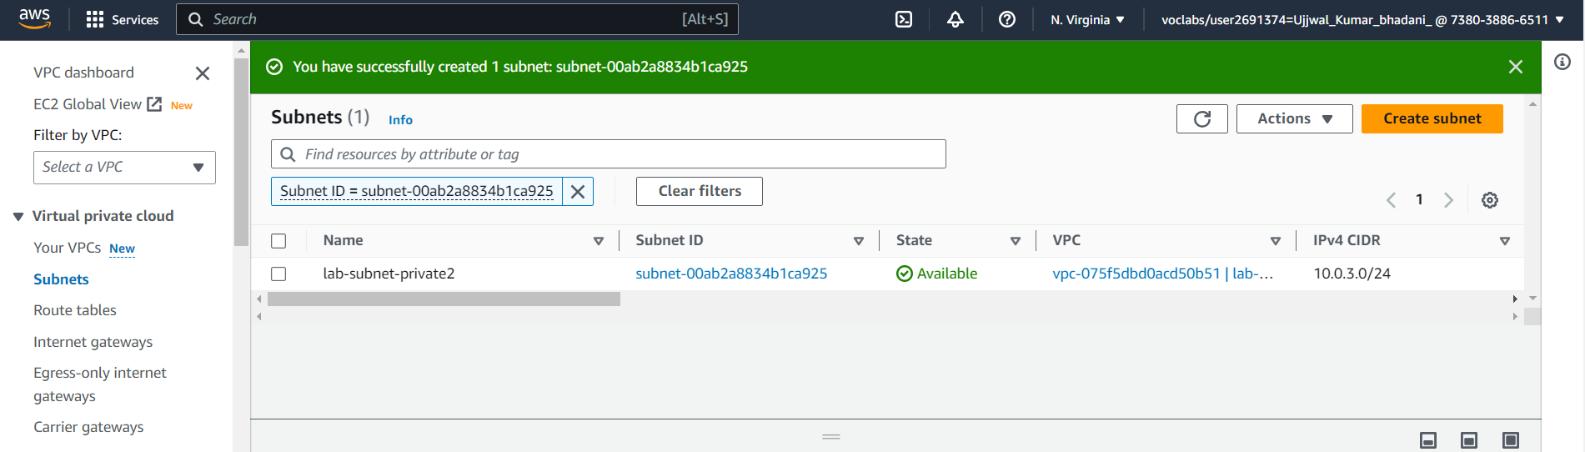

1. Choose Create subnet
2. In the left navigation pane, choose Route tables.
3. Select the **lab-rtb-private1-us-east-1a** route table.
4. In the lower pane, choose the Routes tab.
5. Choose the Subnet associations tab.

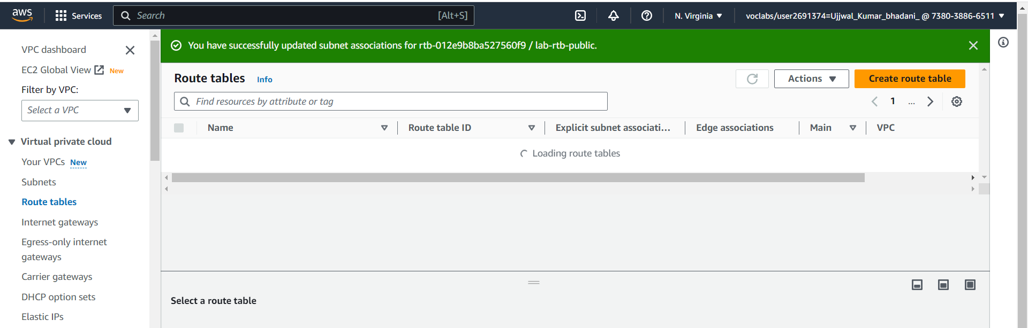

1. In the Explicit subnet associations panel, choose Edit subnet associations
2. Leave lab-subnet-private1-us-east-1a selected, but also select lab-subnet-private2.
3. Choose Save associations
4. Select the lab-rtb-public route table (and deselect any other subnets).
5. In the lower pane, choose the Routes tab.
6. Choose the Subnet associations tab.
7. In the Explicit subnet associations area, choose Edit subnet associations
8. Leave lab-subnet-public1-us-east-1a selected, but also select lab-subnet-public2.
9. Choose Save associations

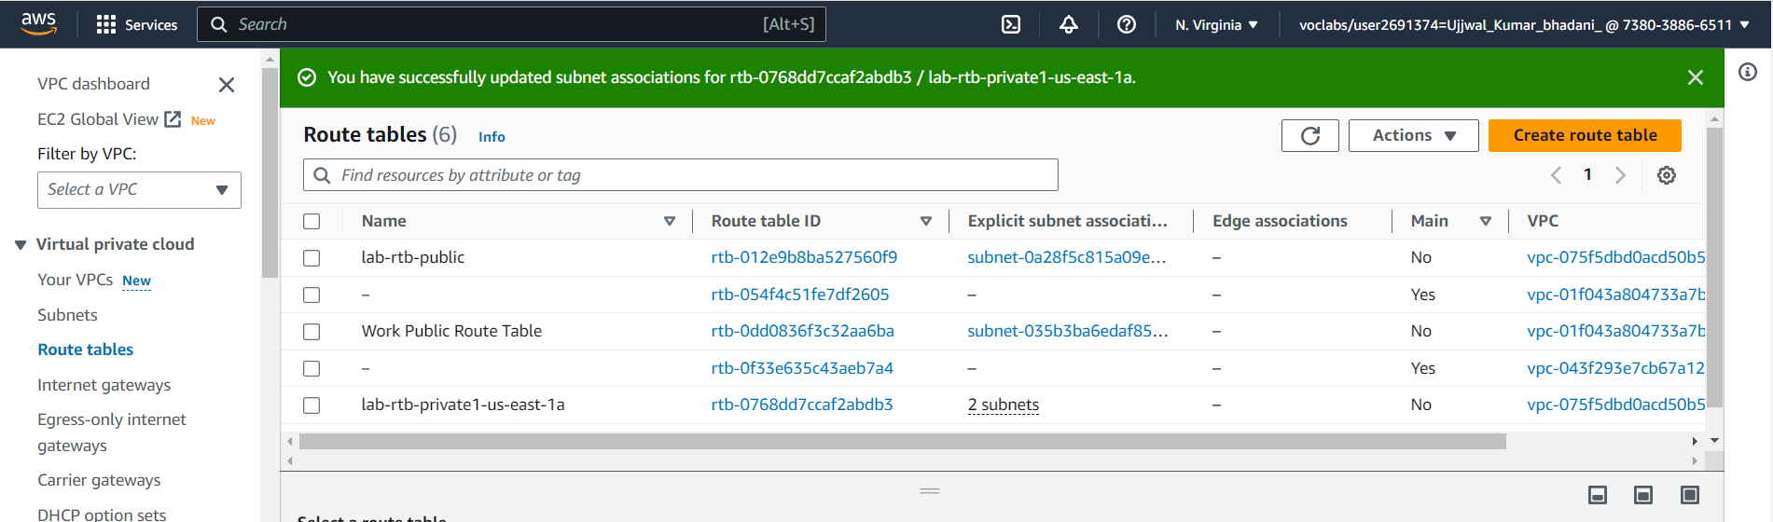

**Task 3: Create a VPC Security Group**

1. In the left navigation pane, choose Security groups.
2. Choose Create security group and then configure:
   1. **Security group name:** Web Security Group
   2. **Description:** Enable HTTP access
   3. **VPC:** choose the X to remove the currently selected VPC, then from the drop down list choose **lab-vpc**
3. In the Inbound rules pane, choose Add rule
4. Configure the following settings:
   1. **Type:** HTTP
   2. **Source:** Anywhere-IPv4
   3. **Description:** Permit web requests
5. Scroll to the bottom of the page and choose Create security group

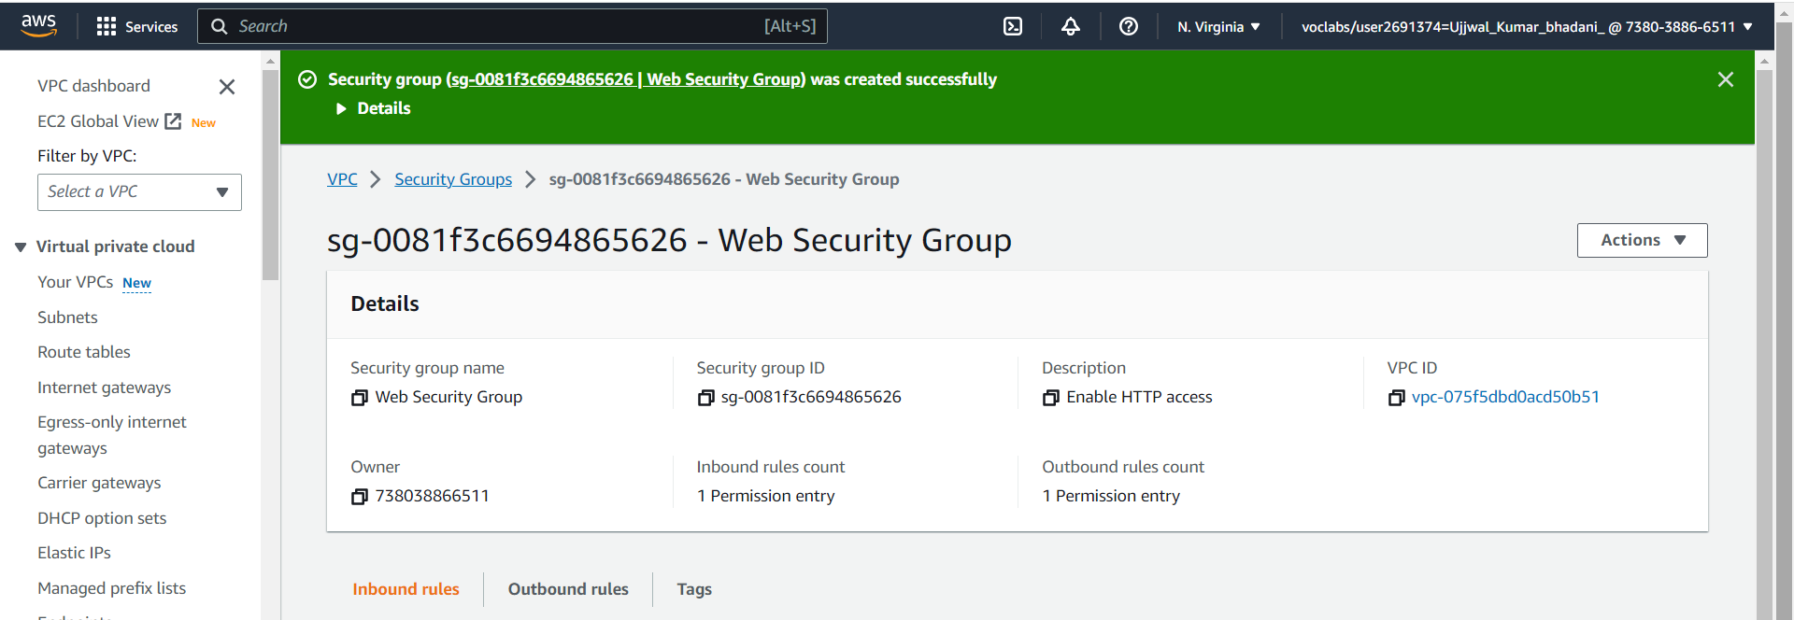

**Task 4: Launch a Web Server Instance**

1. In the search box to the right of Services, search for and choose EC2 to open the EC2 console.
2. From the Launch instance menu choose Launch instance.
3. Name the instance:
   1. Give it the name Web Server 1
   2. When you name your instance, AWS creates a tag and associates it with the instance. A tag is a key value pair. The key for this pair is *Name*, and the value is the name you enter for your EC2 instance.
4. Choose an AMI from which to create the instance:
   1. In the list of available Quick Start AMIs, keep the default Amazon Linux selected.
   2. Also keep the default Amazon Linux 2023 AMI selected.
   3. The type of Amazon Machine Image (AMI) you choose determines the Operating System that will run on the EC2 instance that you launch.
5. Choose an Instance type:
   1. In the Instance type panel, keep the default **t2.micro** selected.
6. Select the key pair to associate with the instance:
   1. From the **Key pair name** menu, select **vockey**.
7. Configure the Network settings:
   1. Next to Network settings, choose Edit, then configure:
      1. Network: lab-vpc
      2. Subnet: lab-subnet-public2 (not Private!)
      3. Auto-assign public IP: Enable
   2. Next, you will configure the instance to use the Web Security Group that you created earlier.
      1. Under Firewall (security groups), choose Select existing security group.
      2. For Common security groups, select Web Security Group.
      3. This security group will permit HTTP access to the instance.

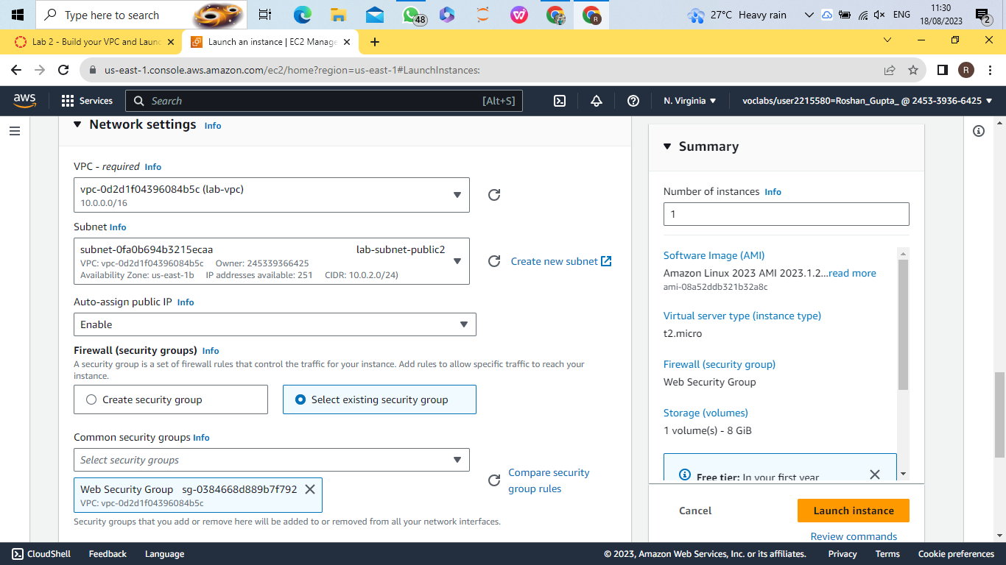

1. In the *Configure storage* section, keep the default settings.
2. Configure a script to run on the instance when it launches:
   1. Expand the Advanced details panel.
   2. Scroll to the bottom of the page and then copy and paste the code shown below into the User data box:
      1. #!/bin/bash
      2. # Install Apache Web Server and PHP
      3. dnf install -y httpd wget php mariadb105-server
      4. # Download Lab files
      5. wget https://aws-tc-largeobjects.s3.us-west-2.amazonaws.com/CUR-TF-100-ACCLFO-2/2-lab2-vpc/s3/lab-app.zip
      6. unzip lab-app.zip -d /var/www/html/
      7. # Turn on web server
      8. chkconfig httpd on
      9. service httpd start
3. At the bottom of the Summary panel on the right side of the screen choose Launch instance

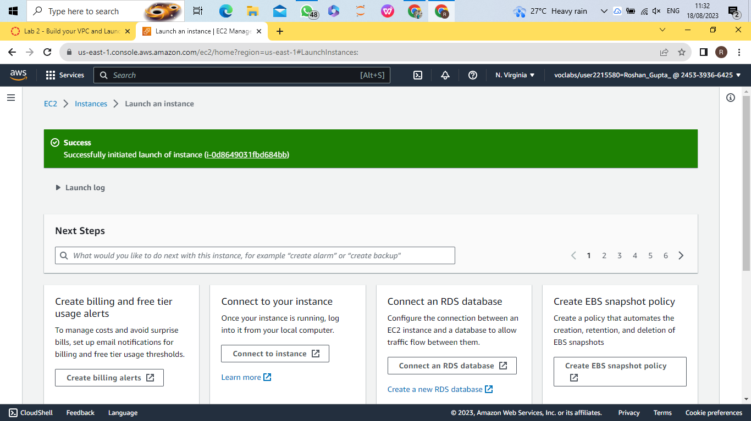

1. Choose View all instances
2. Wait until Web Server 1 shows *2/2 checks passed* in the Status check column.
3. Select Web Server 1.
4. Copy the Public IPv4 DNS value shown in the Details tab at the bottom of the page.
5. Open a new web browser tab, paste the Public DNS value and press Enter.

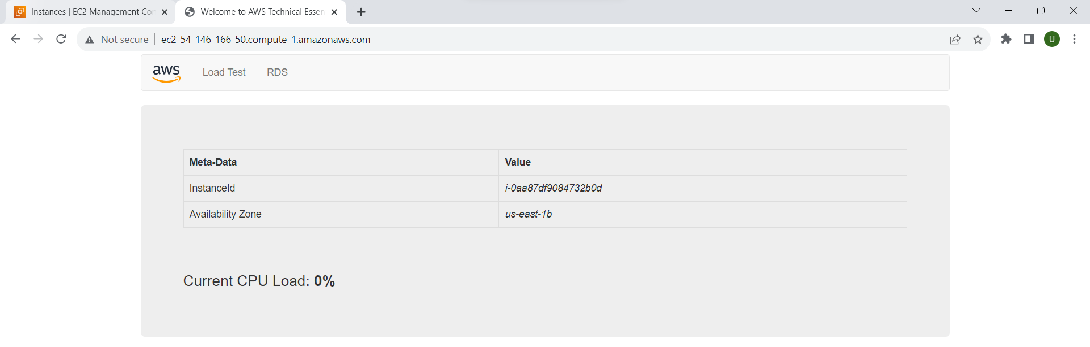

1. Choose End Lab at the top of this page and then choose Yes to confirm that you want to end the lab.

A panel will appear, indicating that "DELETE has been initiated... You may close this message box now."

1. Choose the X in the top right corner to close the panel.

**Submitted By:**

Ujjwal Kumar Bhdani  
2101020286  
CIT21046  
Experiement-3